## BuzzHiveGames Sprint Completion: 7/17/18

# Against the Swarm v.1 (7/24/18) Sprint 2 Plan

**Goal:** Finish core combat system, construct the tech tree, establish the turnaround point of the game, and make it winnable.

**Task Listing: (39 Story Points)**

(5) As a player, I want to be able to reclaim towns, so that I can eventually fight the swarm back to its home realm, kill it, and win the game.

* Create button to reclaim towns; this button is enabled when you push the invasion progress variable beyond a destroyed town. 15
* When you click the button to reclaim towns, the game shifts into a “reclaim mode,” and the game’s timers are stopped until you disengage or kill all of the enemies. 60
* Disable enemy respawning in “reclaim mode.” 15
* Set reclaimed town as the player’s current location, re-enable the timer, and push the invasion progress back by 10. 15

(2) As a player I want to be able to use Follower Resource to hire fighters to join my party, so I can more effectively fight the swarm.

* Make a button that hires fighters. 5
* Add a fighter object to the player’s party. 5
* Reduce the player’s follower_resource by some number. 5
* Disable the button when there isn’t enough follower_resource. 10
* Store the cost of fighters in the Follower object. 5

(5) As a player, I want to hire a Magic User with an attack that charges up and does damage in a burst, so that I can overcome enemies with high damage-reduction.

* Make fighters have an attack function and make the Magic User a fighter with an alternate version. 15
* Magic User needs a “charge” variable to store how close it is to attacking and a number that they fire at when they have a full charge. 5
* Magic Users need to lose charge after they attack. 5
* I want monsters to break a Magic User's concentration when they hit so that Magic Users can only cast if they avoid damage. 15
* Make a button that hires Magic Users. 5
* Add a Magic User object to the player’s party. 5
* Reduce the player’s follower_resource by some number. 5
* Disable the button when there isn’t enough follower_resource. 10
* Store the cost of magics in the Follower object. 5

(3) As a game designer, I want technologies in the tech-tree to be hidden until the player has researched the prerequisite technologies, so that there is an air of mystery about the tree’s progression. (Brandon Pham)

* When choosing what technologies to display, loop through the player’s prerequisites. If the player has the prerequisite, the technology is displayed. 30
* Get technologies displayed with Vue. 30

(3) As a game designer, I want to be able to lock and unlock various follower types, so that I control the pace of the game for the player.

* Set boolean for each follower type that controls whether the hire button is visible to the player or not. 30
* Write a function that can change that boolean. 10

(8) As a game designer, I want the number of followers that the player can take with them when they retreat to a new world to be limited, so that they have to make decisions about who to take with them and if they will hire more miners/teleporters in the next world.

* Make a variable to count crystals in player inventory object. 5 Jacob
* Make a modal (pop-up) box can be displayed and pauses the rest of the game when displayed. 120 Jacob
* Display all of the followers/fighters in the modal with numbers. 30 Jacob
* Add followers and fighters to your escape party. 15 Jacob
* If you have a valid escape party, you can click teleport. 20 Jacob
* This modal pops up when you leave a world. 15 Jacob
* You lose all the fighters/followers not in your escape party. 10 Jacob

(5) As a player, I want to gain resources over time and from fighting monsters.

* Each round I fight while Under Siege, I want to gain resources (resources are converted and gained based on follower resource), so that I have more resources when the siege breaks through. (All resources gained overtime are incremented here.) 20
  + Buzz Tilford
* I want to gain meat, scales, and claws when I kill enemies. 10
  + Buzz Tilford
* I want to gain fiber, metal, and gelatin on an overtime if I have the correct followers. 10
  + Buzz Tilford
* I want to gain ore overtime based on the number of miners I have. 10
  + Buzz Tilford
* I want to gain crystals overtime based on the amount of ore and number of teleporters I have. 10
  + Buzz Tilford

(8?) As a player, I want to be able to see gameplay represented visually, so I can quickly understand and react to the game state. (Andrew Kim) (Total 18 hours)

* Small Icons for followers (Followers, Meat Pounder, Scale Forger, Claw Grinder, Fighter, Pyromancer, Aether Miner, Enchanter) 2 hours
* Small Icons for resources (Meat, Scales, Claws, Fiber, Metal, Gelatin, Aetherium, Telecrystals) 2 hours
* Small Icons for invasion progress bar (Town, Fire, Destroyed Town, Swarm) 1.5 hours
* Knight Sprites (Idle, Attack, Guard, Death animations) 2 hours
* Wizard Sprites (Idle, Charge, Attack, Death, Energy Ball animations) 2 hours
* Buttons (Fight, Guard, Disengage, Rest, Engage) 1.5 hours
* 3 types of Monsters (spider, scalisk, crab) (each with Idle, Attack, Death) 6 hours
* Tab Icons (Flask, Book, Floppy Disk, Gear) 1 hour
* Make the invasion bar look more fluid (30) (Michael)
* Make the invasion bar use vue (1hr) (Michael)

(5) As a player, I want to be able to be able to convert processed items into technologies by clicking options in an on-screen tech-tree so that I can increase the effectiveness of my fighters, my followers, and construct the secret weapon that destroys the swarm.

* Put onclick listener on researched technologies and call a function that attempts to unlock the said technologies. 30
* If the player can pay for it from the player inventory, unlock it and call the operation functions belonging to the unlocked technology. 30

(3) As a player, I want to be able to take an action in combat that shields my Magic Users so that I can charge them up while letting my tougher fighters soak damage so that my Magic Users will be able to attack more reliably.

* Create guard() function with button. 15
* Make guard() like multi-fight function except that fighters do not attack, and all monster attacks go to fighters, not Magic Users, if there are any fighters. 15
* In guard(), Magic Users can still attack. 15

(3) As a designer, I want a Boss Monster to be engaged when a player attempts to reclaim towns, so that reclaiming territory is a challenge. (Michael)

* Make boss monster spawn when wave is pushed back to another town (1hr)
* During boss fight, no other enemies will spawn (15)
* If boss is defeated, then the current town becomes the players location and the wave is pushed back by ten units (15)

(5) As a Designer, I want all my game logic variables and functions to be all in one class so that it will be easier to read the code and also make it possible to save the game if we have time.

(Michael)

* Change game_logic.js file so that all functions and variables are under game class (30)
* Make sure all functions do not need parameters (10)
* Make sure the rest of the files have their variables changed so that it works (30)

**Team Roles:**  
Buzz Tilford: Product Owner

Jacob Swanson: Scrum Master

Andrew Kim: Developer, Artist

Zeyuan Jiang: Developer

Jolene Nguyen: Developer

Brandon Pham: Developer

**Initial Task Assignment:**

Buzz Tilford:

Zeyuan Jiang:

Andrew Kim:

Jolene Nguyen:

Brandon Pham:

Jacob Swanson:

**Initial Burn Up Chart:**

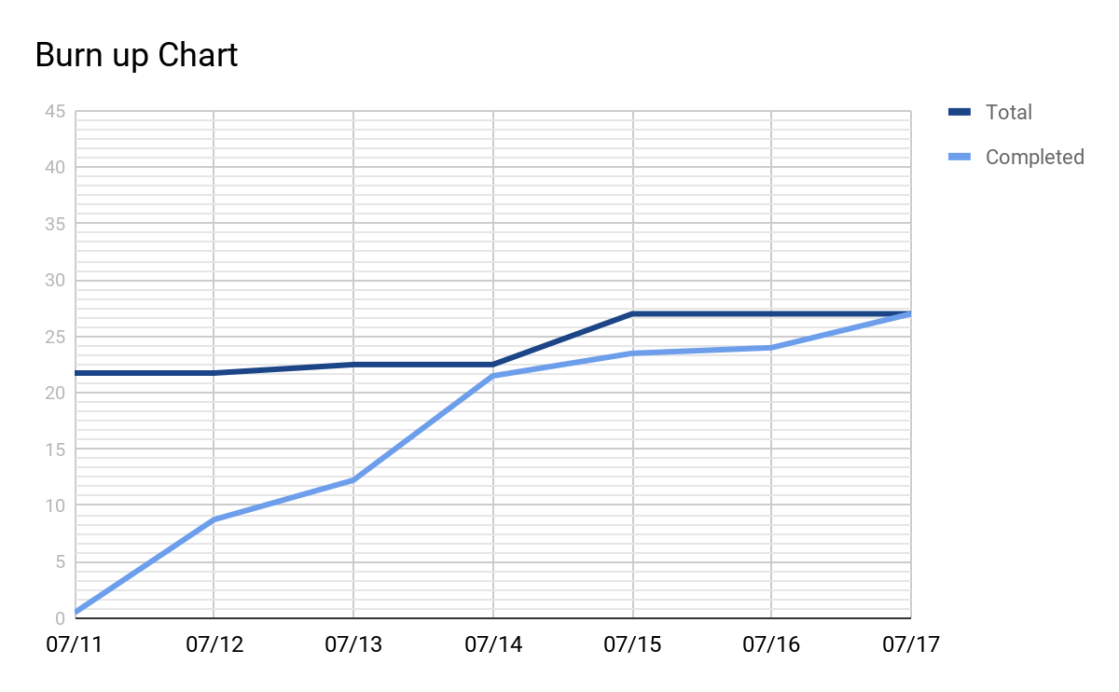

**Initial Scrum Times:**

Tues 12:00 PM with TA BE 340A

Thur 5:30 PM with TA BE 340A  
 Sun 10:00 AM BE 316

**Scrum Board:**

<https://trello.com/b/IKjjFwoM/sprint2>